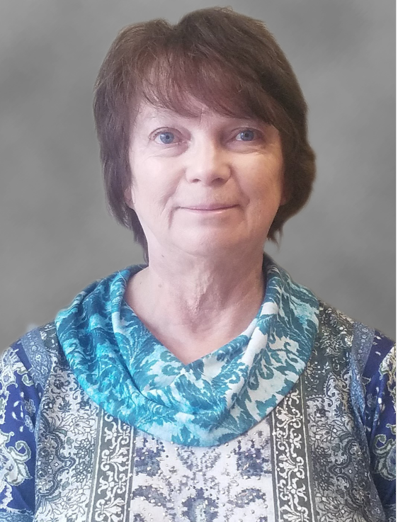
Northwoods Credit Union Announces Retirement of Mary Golen.
Northwoods Credit Union Chief Lending Officer/Executive Vice President, Mary Golen, has announced her plan to retire in December, after 21 years. Mary has held a leadership role here at Northwoods and has helped lead us through adding new offices, a merger, multiple system conversions and huge growth. Mary championed a way of lending that encouraged the “people helping people” philosophy where credit union loan approval focuses more on people and their stories more than their credit score. She has been an major player in instilling this culture throughout the credit union, seeing our members as people and not a number and understanding that bad things happen to good people.
When Mary first joined the credit union back in 1999 as a teller, we had one office on Avenue B, prior to the addition. She soon became a loan officer, then a mortgage loan officer, collections manager and in 2004 Mary began leading our lending team. At that time Mary led a team of 5 loan officers. Today, Mary’s team has grown to 13 with a full mortgage department along with our consumer lending department.
Northwoods Credit Union CEO, Doug Wolf, said, “Our SPICE Values of Servant Mentality, Progressive Thinking, Integrity, Compassion and Empathy were always lived by Mary and her influence created this culture long before we put these values in writing. We will never be able to thank Mary enough for her leadership and her vision of what lending should be.”
We are disappointed that we cannot celebrate Mary with a retirement party at this time due to the global pandemic. If you would like to share well-wishes, please contact Mary via:
Email: ncu@northwoodscu.org
Facebook
Mail: Northwoods Credit Union
Attn: Mary Golen
1702 Ave B
Cloquet, MN 55720

